Ideation Phase

Define the Problem Statements

|  |  |
| --- | --- |
| Date | 19 September 2022 |
| Team ID | IBMSI20220014364 |
| Project Name | Car resale value prediction |
| Maximum Marks | 2 Marks |

**Customer Problem Statement:**

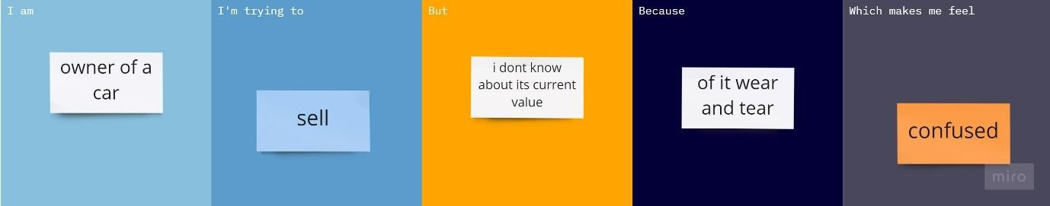

|  |  |  |  |  |  |
| --- | --- | --- | --- | --- | --- |
| **Problem**  **Statement (PS)** | **I am**  **(Customer)** | **I’m trying to** | **But** | **Because** | **Which makes me feel** |
| PS-1 | Owner of a car | Sell | I don’t know about its current  value | Of it wear and tear | Confused |
| PS-2 | Owner of a car | Find its resale value | I am concerned about the  minor dents | Of a small accident | A little worried |